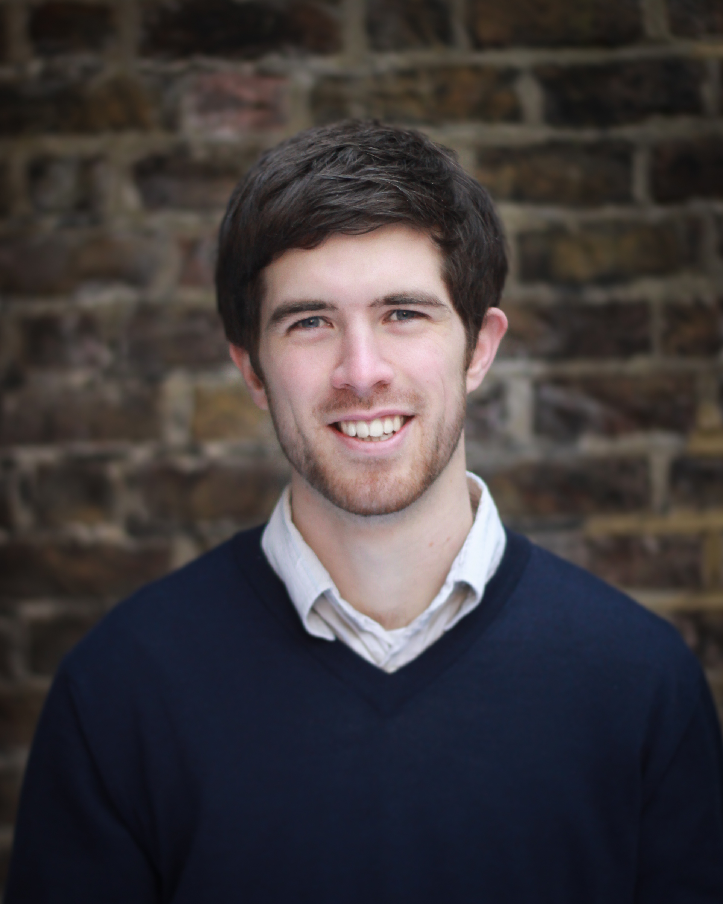
Patrick Stockbridge
Curriculum Vitae

Flat 20 Tiptree, Castlehaven Road, London, NW1 8TL
p.stockbridge@hotmail.co.uk - 07757 487168

Work Experience

September 2011 - current: Freelance Musical Director, Composer and Pianist

Musical Director (and Pianist/Keys 1) credits:

UK Tours
Blood Brothers (AMD) - 12 Jan – 16 Apr; 12 Sept – 26 Nov 2016 (Bill Kenwright Ltd., No. 1 UK Tour)
TV
Two Wolves (Music by Trisha Ward) - Various 2018 (Lupine Productions, BBC/Netflix Pilot)
Pantomime
Aladdin - 8 Dec 2018 – 3 Jan 2019 (Upstage Productions, Radlett Centre)
Jack And The Beanstalk - 2 Dec 2017 – 1 Jan 2018 (UK Productions, Bournemouth Pavillion Theatre)
Other Musicals
NORMality (Arranger/MD) - 13-21 Sept 2019 (The Other Palace)
Ed Fringe: The Musical Revue (Composer/MD) - 1 - 27 Aug 2018 (Mixed Revue Theatre Co., Edinburgh Fringe Festival)
The Happy Funeral (MD/Arranger) - 23 May 2017 – 3 June 2017 (Market Theatre, Hitchin, Herts)
Southern Baptist Boys (Supervisor/Arranger) - 8 Mar 2017 – 22 Apr 2017 (Above The Stag, London)
The Pet Shop Boys’ ‘Closer To Heaven’ - 22 Apr – 24 May; 21 Oct – 28 Nov 2015, (Paul Taylor Mills, Union Theatre)
News Revue - 6 Mar – 29 Mar 2015 (News Revue - Canal Café Theatre, London)

SEN Education work:
- Workshop leader (with composer colleague William Carslake) on creative composition projects with children from SEN schools in Telford, Reading, Warwick, Birmingham and London. Working with children on a topic familiar to them with visual, sensual and musical stimulus to write their own lyrics and musical ideas which are then complied into a short (10-15minute) theatrical piece. These projects have been funded by Armonico Consort (2015/16/18) and Camden Music Hub/English Pocket Opera (2016).
- A Radio 4 Programme followed the process of one of these workshop weeks. Link attached: https://www.bbc.co.uk/programmes/b09h361g
- Associate Choir leader Unity Choir, a community inclusive choir in Hammersmith and composer for Turtle Song, music for Dementia patients, both run through charity and theatre producer, Turtle Key Arts.

Other Outreach, Composing Orchestrator and Pianist work:
- Recent Compositional works:
- The Nutcracker (Children’s Show) Reading Rep, Dec 2020, Dec 2019
- Alby (Children’s Show) Oxford Playhouse, Dec 2018, Reading Rep, Dec 2017
- Ed Fringe: A Musical Revue (Cabaret), Edinburgh Fringe 2018
- January: A Musical Revue (Cabaret), Canal Café Theatre, Jan 2016; Brasserie Zedel, Jan 2017
- Workshop leader and MD for choir creation projects in schools across the country and workplace choir scheme ‘Voice Squad’ in London and Coventry.
- Pianist for improvised comedy groups Grand Theft Impro, Monkey Toast, Séance Fiction & Notflix.
- Accompanist for a variety of choirs, youth and amateur musical theatre groups and arts projects.
- Associate MD at Emil Dale Academy, Hitchin and Stella Mann College, Bedford.
- Artist in Residence at Ark Music and vocal coach at Hackney Music Development Trust.

Academic:

September 2008- June 2011: University of Birmingham
- BA Music and Mathematics - 1st class honours
(specialising in Composition and Orchestration)

September 2001- June 2008: Hitchin Boys School
- June 2008 – 4 A Levels: Music (A), Maths (A), Geography (A), Further Maths (A)
- June 2006 – 11 GCSE’s including Maths, English and 3 Sciences: 9A*’s, 2A’s

Other Academic Achievements:
- ABRSM Grade 8 Distinction on Piano and Trumpet
- Peter Lambourne Youth Bursary for Music in North Hertfordshire

References

Helen Eastman – heeastman@gmail.com
Freelance Director, Writer (and frequent collaborator)

Gaynor Larkin – glarkin@armonico.org.uk
Head of Education – Armonico Consort

